Instructions on how to upload and use the Corporate Background(s)
- Save the backgrounds you want to use to your device

2) When you join your next meeting, on your task bar, click the three dots, and select Background
3) The right hand of the screen opens up to select a background, at the very top there is an option to add a new background
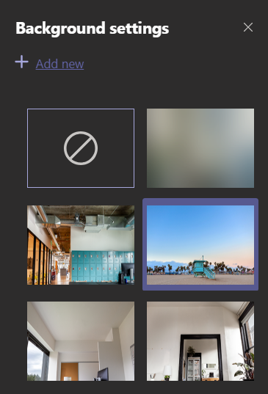
4) Select the background(s) you have saved to your computer.
5) Note that to you it may look inverted – to those on the call with you it will be the right way around
6) Teams now ‘remembers’ the background you chose, so it will automatically open with that background for future meetings.

