Drop-in Clinics:
You must book a slot for your Drop-in session by calling our booking line on 0141 314 4604 on a Wednesday between 10am-12noon. You can attend any clinic.
You can choose between a Face to Face Drop-in session or a Digital appointment.
You do not attend the clinic for a Digital appointment.

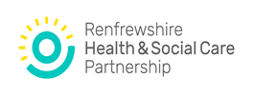

Speech & Language Therapy
Drop-in Advice Clinics
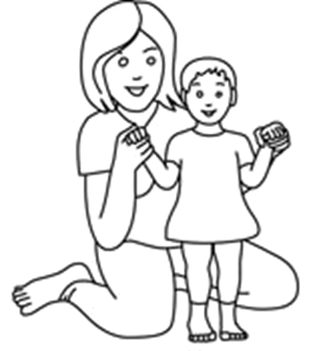
Renfrew Health and Social Work Centre  10 Ferry Road  Renfrew  PA4 8RU | Monday – once a month
Johnstone Health Centre  60 Quarry Street  Johnstone  PA5 8EY | Tuesday – once a month
SLT Advice Line  (Advice for both Parents and Professionals) | Wednesday – weekly  10 – 12 noon  0141 314 4624
Aranthrue Centre  103 Paisley Road  Renfrew  PA4 8LH | Thursday – once a month
Erskine Health Centre  Bargarran Square  Erskine  PA8 6BS | Friday – once a month

For Children & Families living in Renfrewshire

Speech & Language Therapy Department
 0141 314 4604

What is a Speech and Language Therapy
Drop-in Clinic?

The Drop-in Clinic is a session for parents/carers who want advice about their child’s speech and/or language development. You will have the opportunity to discuss your child’s development with a Speech and Language Therapist.

Your health visitor, GP or your child’s nursery/school may recommend that you access one of our Drop-in Clinic sessions. They are open to families who live in Renfrewshire.

There are both Face to Face and Digital Drop-in sessions available at clinics across Renfrewshire. You can attend any session with your child, no matter where you live Renfrewshire.

Please phone our booking line on a Wednesday between
10-12 to book your Drop-in session. The phone number is 0141 314 4604.

What will happen at the Drop-in Clinic?
We will ask you to tell us about your child’s speech, language and communication development. We will give you advice on how to support your child to develop their speech, language and communication skills including tips to try at home or useful web sites to look at.

We may do a short evaluation of your child’s speech and language skills using simple screening checklists with you or we may do this by watching and joining in with your child in play activities.

We may agree the next step for your child, which might include a therapy home pack or a referral for a detailed assessment by a Speech and Language Therapist.

Clinics are held each month at clinics across Renfrewshire. You can attend any session with your child, no matter where you live Renfrewshire.
Please note that you must be the parent or legal guardian of the child accessing the Drop-in Clinic. We will be unable to continue with the consultation if this is not the case.

